**These are the steps to see the application online on your web browser.**

Steps to run the Application :

1. Open the link :

<https://singapore-resale-price-prediction-ma5m.onrender.com/>

1. You will see the below page opening up:

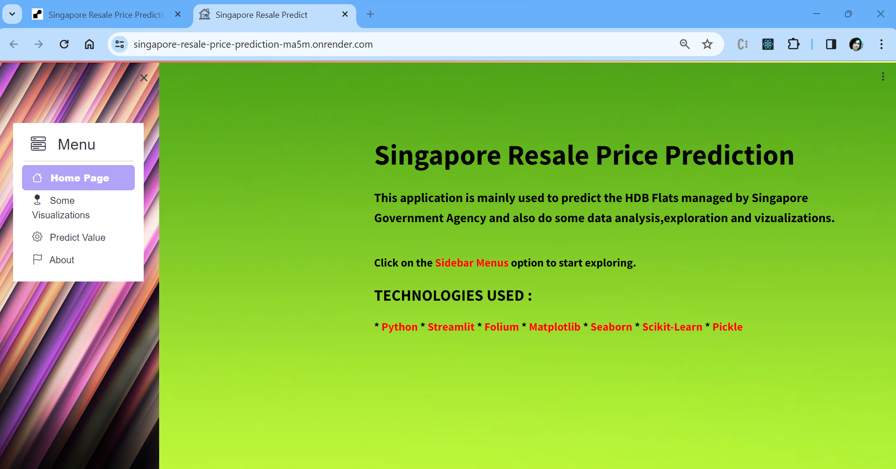

1. Go to “Predict Value” tab to open up the form. Fill in the required details and finally click on “Predict Resale Price” button.

1. We can see the Predicted Resale price as well as the Evaluation Metrics to see the model’s accuracy.

